Chi Square for Goodness of fit:

In 2010 census of the city, the weight of the individuals in a small city were found to be the following?

|  |  |  |
| --- | --- | --- |
| <50 kg | 50-75 kg | >75 kg |
| 20% | 30% | 50% |

In 2020, the weight of n = 500 were sampled. Below are the results

|  |  |  |
| --- | --- | --- |
| <50 kg | 50-75 kg | >75 kg |
| 140 | 160 | 200 |

Using $α$ = 0.05, would you conclude the population differences of weights has changed in the last 10 years?

Ans:

Expected data: 2010

|  |  |  |
| --- | --- | --- |
| <50 kg | 50-75 kg | >75 kg |
| 20% | 30% | 50% |

Observed data: 2020, n = 500

|  |  |  |
| --- | --- | --- |
| <50 kg | 50-75 kg | >75 kg |
| 140 | 160 | 200 |

|  |  |  |  |
| --- | --- | --- | --- |
|  | < 50 kg | 50-75 kg | >75 kg |
| Expected | 100 | 150 | 250 |
| Observed | 140 | 160 | 200 |

1. Null Hypothesis: $H_{0}$: The data meets the expectation.

2. Alternate Hypothesis: $H_{1}$: The data does not meet the expectation.

3. Significance value = $α$ = 0.05

Therefore, Confidence Interval = 95%

4. Degree of Freedom = No. of categories (k) – 1 = 3 – 1 = 2

5. Decision Boundary:

In the case of Chi Squared test, we do not have a symmetrical distribution

We need to find a critical value based on the significance level

If we get a value after applying chi squared statistics that is greater than the critical value, we reject the null hypothesis.

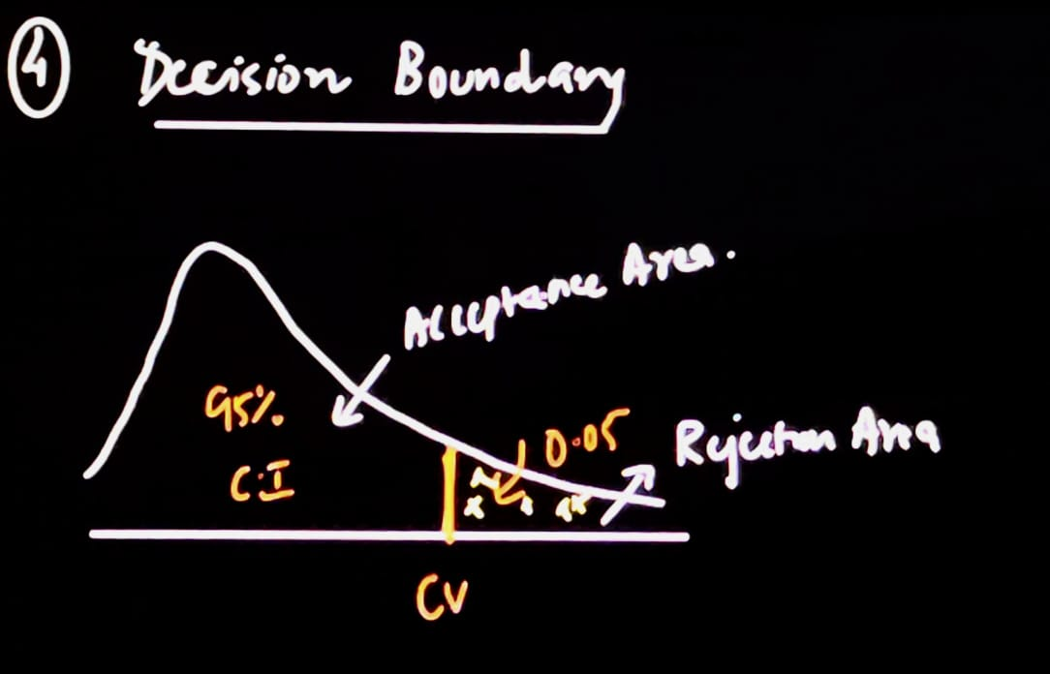

To get the critical value, we will refer to the chi square table using the Degree of Freedom value and Significance level value. (On top of the table, we have the significance level and on the left side, we have the degree of freedoms)

After cross referencing the table, we get the critical value as 5.991

Notation for chi squared test: $X^{2}$

If $X^{2}$ is greater than 5.99, reject the null hypothesis

Else we fail to reject the null hypothesis

6. Calculate chi squared test statistics:

Formula:

$X^{2}=\sum{\frac{{Observed-Expected)}^{2}}{Expecred}}$ = $\frac{{(140-100)}^{2}}{100}$ + $\frac{{(160-150)}^{2}}{150}$ + $\frac{{(200-250)}^{2}}{250}$ = 26.66

Since $X^{2}$ is greater than 5.99, we reject the null hypothesis.

Therefore, we can conclude the weights of 2020 population are different than those expected as per 2010 popuation.